### **20. SPANNING TREE PROTOCOL (STP): PART 1**

### **Redundancy in Networks**

* **Importance:** Networks are designed for 24/7/365 availability, and redundancy ensures minimal downtime during component failures.
* **Challenge:** Redundancy can create Layer 2 loops, leading to **broadcast storms** and **MAC address flapping**.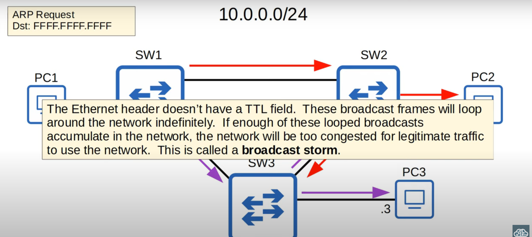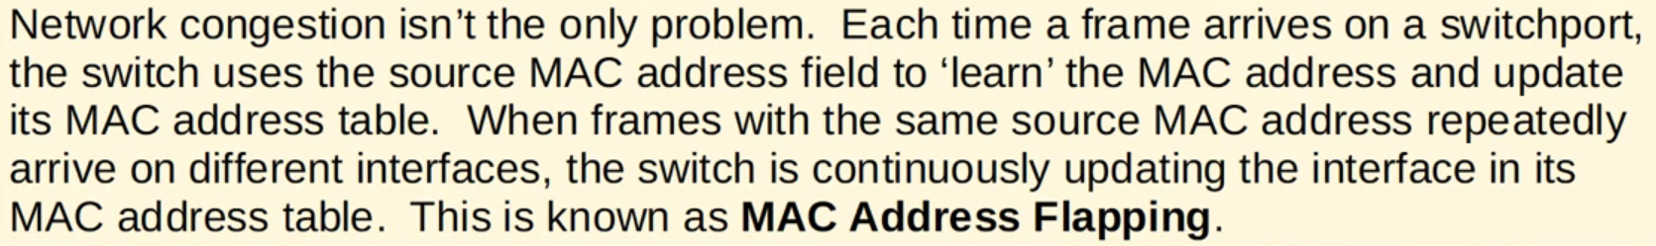

### **Spanning Tree Protocol (STP) Overview**

* **IEEE Standard:** 802.1D (Classic STP).
* **Goal:** Prevent Layer 2 loops by placing redundant ports into a **blocking state**.
* **Behavior:**
  + Blocked ports only send/receive **BPDUs (Bridge Protocol Data Units)**.
  + Automatically adjusts topology when active ports fail.

### **Key STP Concepts**

1. **Root Bridge Election:**
   * Switch with the **lowest Bridge ID** becomes the **Root Bridge**.
   * Tie-breaker: Lowest MAC address.
   * All ports on the Root Bridge are **Designated Ports (Forwarding State)**.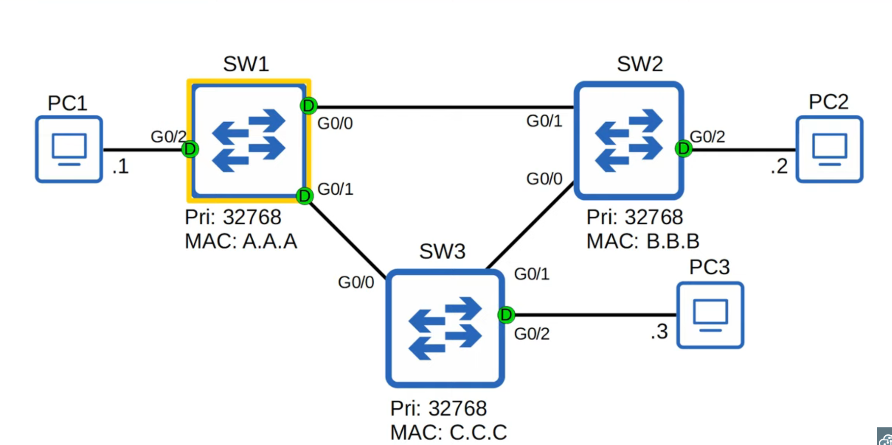
2. **Root Port Selection (per switch):**
   * Chosen port to reach the Root Bridge.
   * Criteria (in order):
     1. Lowest **Root Path Cost**. (Take note for exam)

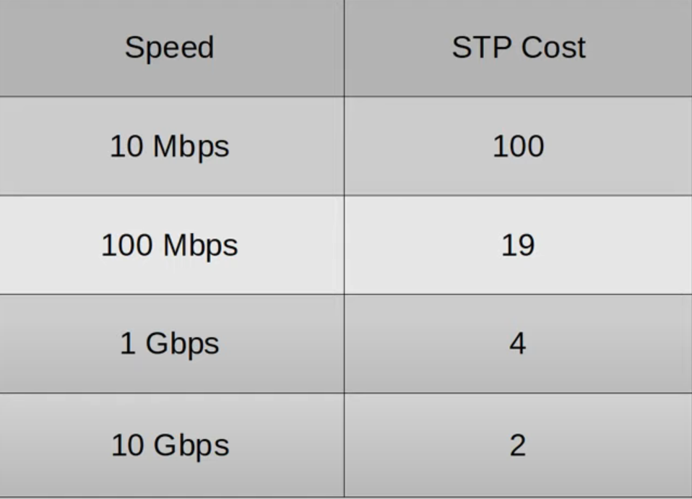

* + 1. Lowest Neighbor Bridge ID.
    2. Lowest Neighbor Port ID.

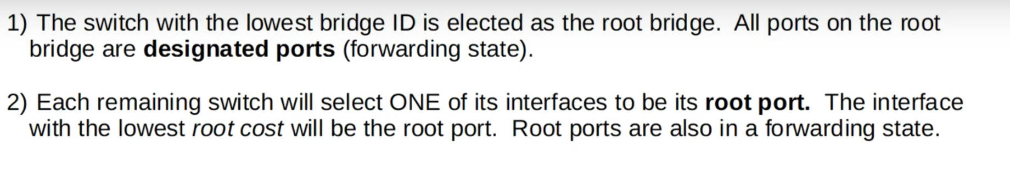

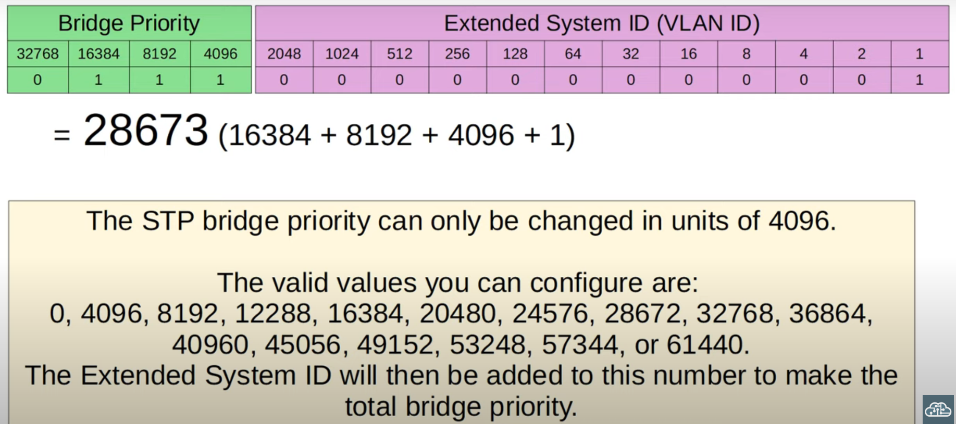

1. **Designated Port Selection (per collision domain):**
   * One port forwards traffic; others block.
   * Criteria (in order):
     1. Lowest **Root Path Cost**.
     2. Lowest Bridge ID.
2. **Blocked Ports:**
   * Prevent loops by stopping redundant paths.

### **BPDU (Bridge Protocol Data Unit)**

* **Purpose:** Used to elect the Root Bridge and communicate topology information.
* After convergence, only the Root Bridge generates BPDUs, and other switches forward them.

### **Steps in STP Operation**

1. Elect a **Root Bridge**.
2. Select a **Root Port** for each non-root switch.
3. Determine **Designated Ports** and **Blocked Ports** in each collision domain.
4. Use the **STP Cost Chart** to calculate Root Path Cost (based on bandwidth).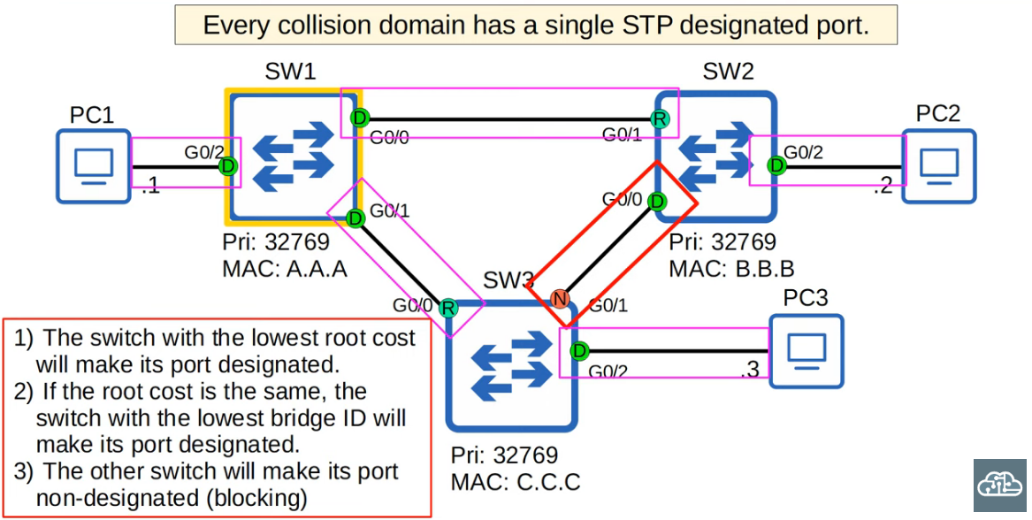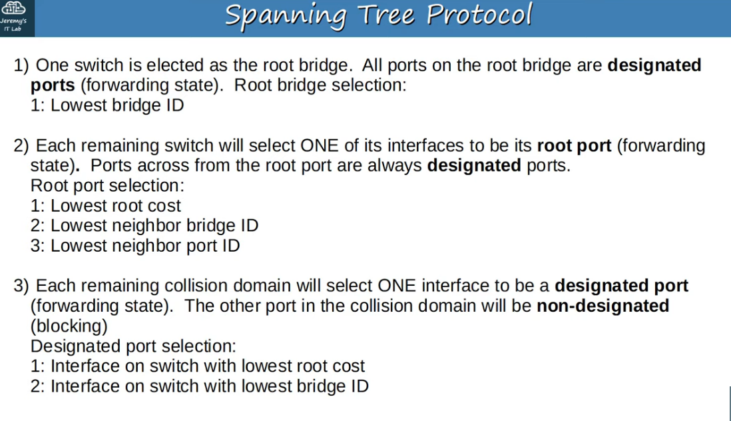

### **STP Cost Chart**

* Costs are based on outgoing interface bandwidth
* **Root Path Cost:** Sum of all outgoing interface costs to the Root Bridge.

### **Key Takeaways**

* STP ensures **loop-free Layer 2 networks** while maintaining redundancy.
* Proper Root Bridge selection and port states (Forwarding/Blocking) prevent network instability.

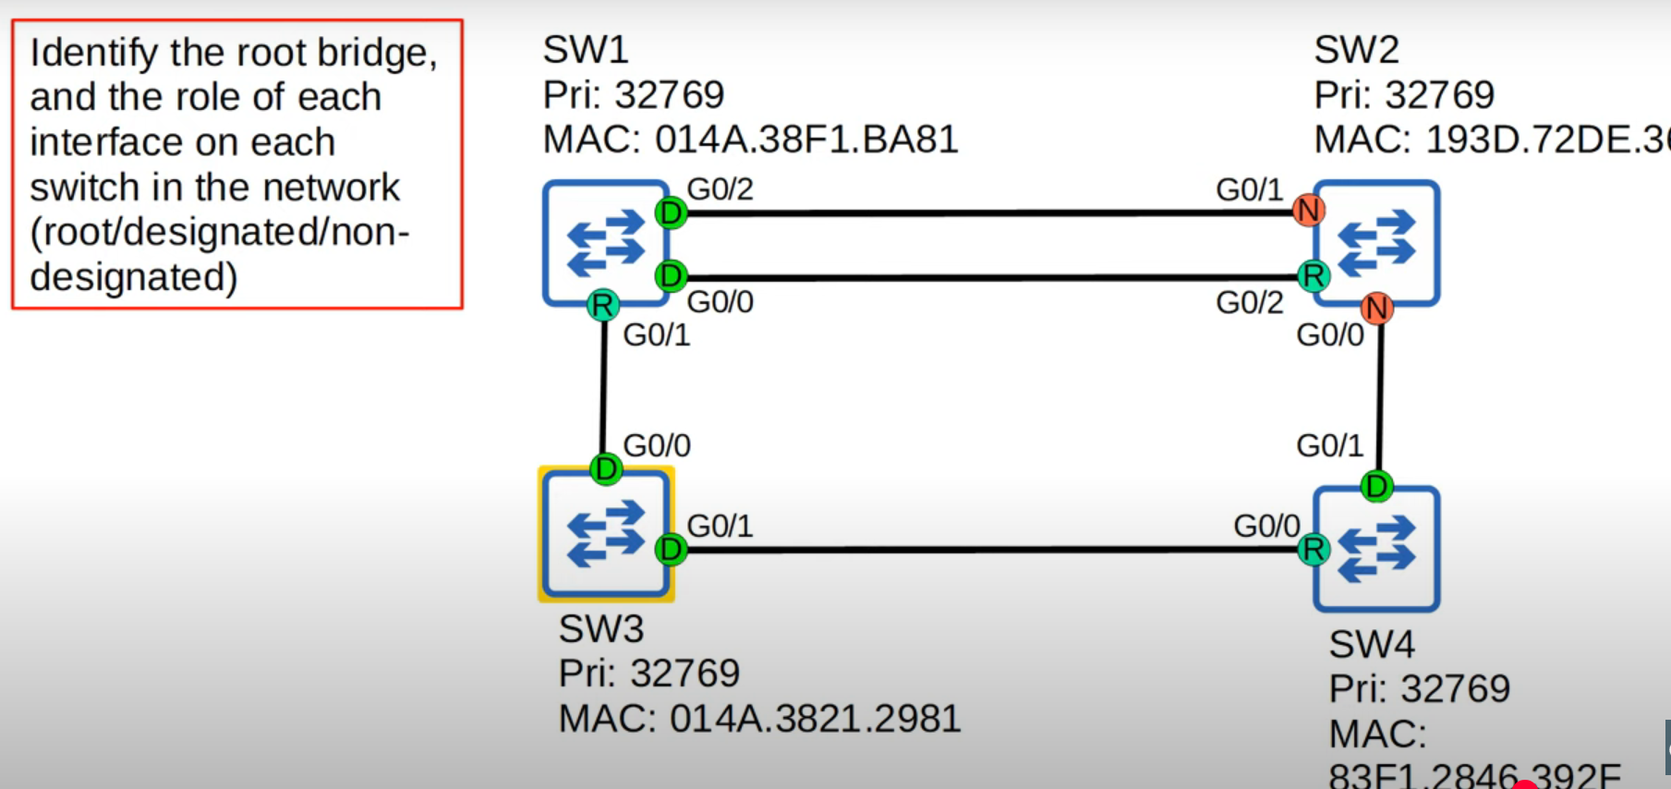

G0/1 and G0/0 on SW2 is non designated due to having higher root cost than SW 1

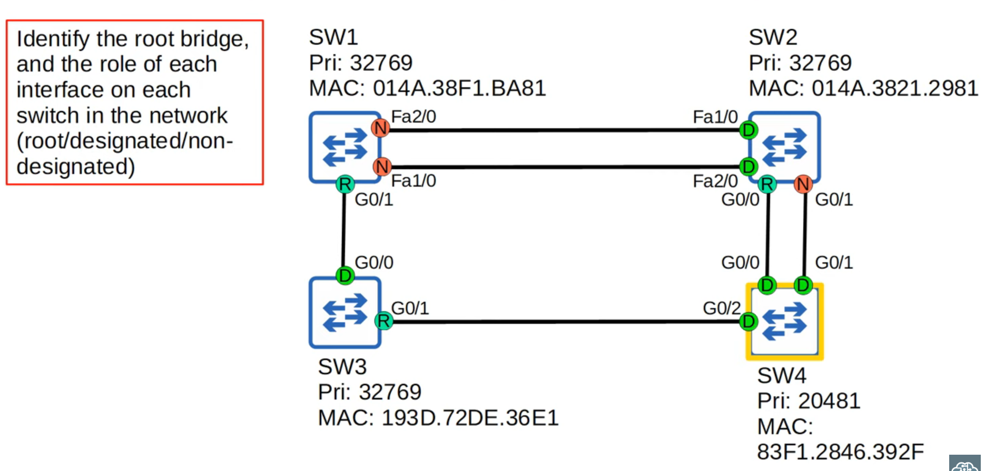

Fa1/0 and Fa2/0 on SW2 is designated due to having lower root cost than SW 1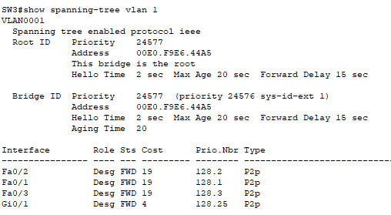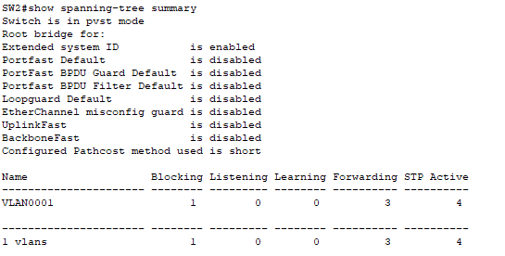

CLI:

* #show spanning-tree vlan 1
* #show spanning-tree detail
* #show spanning-tree summary